**Welker’s Wikinomics Self-Guided Notes** -*Money Markets*

*Define the following terms and complete the labeling of the graph as you listen to Mr. Welker’s Lecture.*

**The Money Market –**

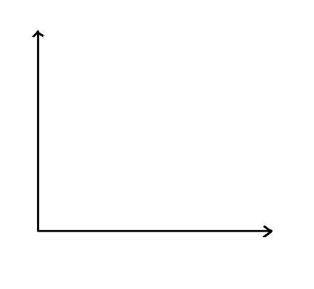

**Money Supply –**

**Money Demand –**

**Equilibrium Interest Rate –**

**What is the difference between contractionary and expansionary policies?**

**What is the relationship between the money market and interest rates?**

**Welker’s Wikinomics Self-Guided Notes** –*Tools of Monetary Policy*

*Define the following terms and complete the graphic organizer as you listen to Mr. Welker’s Lecture.*

**What do commercial banks hold as assets?**

**What do households hold as assets?**

|  |  |  |
| --- | --- | --- |
| **The Federal Reserve System**  *How can the Fed increase or decrease the money supply in the economy?* | | |
|  | What happens if it’s raised or sold? | What happens if it’s lowered or bought? |
| **Reserve Requirement Ration**  **“RRR” is defined as:** |  |  |
| **OMO**  **“ _________ _____________**  **________________” is defined as:** |  |  |
| **Discount Rate is defined as:** |  |  |

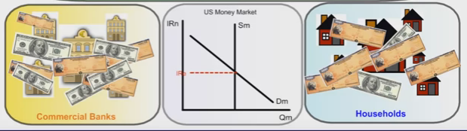

**Which tool is most preferred by the Federal Reserve?**

**During a recession, the Fed will engage is ____________________________ monetary policy.**

**During inflation, the Fed will engage in _________________________________ monetary policy.**